WEEK 7 LEARNING OUTCOMES

Upon completion of this session, students should be able to:
- Understand the use and application of CSS Class and ID Selectors
- Understand the difference between Class and ID Selectors
- Apply Class and ID Selectors to appropriate HTML elements
- Understand the use and application of CSS positioning properties
- Use DIVs and CSS positioning properties to layout documents
- Understand the use of Descendent Selectors

Wherever possible, you should try to use tags in compliance with the specification for HTML 5.

Within, this document, tags are shown in capitals for purposes of clarity and emphasis.

Points to remember when creating / using CSS:

1). Your CSS (internal or external) should not contain any html tags.

2). Your CSS should always use the American spelling: COLOR.

3). Your external CSS files should be saved with a .css extension.

4). Inline styles (those directly applied in the code) take precedence over
Internal (in the <head>), or external style sheets. This is due to the
Cascading Order (see slide 9 of week 7 lecture).

TASK 1: USING ID SELECTORS TO FORMAT DIV TAGS Page 2

TASK 2: USING CLASS SELECTORS Page 3

TASK 3: USING DESCENDENT SELECTORS Page 4

TASK 4: POSITIONING USING ABSOLUTE VALUES Page 5

TASK 5: POSITIONING DIVS USING CSS LIQUID LAYOUTS Page 6

SELF-STUDY TASKS FOR WEEK 7 Page 7

TASK 1: USING ID SELECTORS TO FORMAT DIV TAGS

One of the problems with internal (embedded) CSS is that it becomes difficult to apply different declarations/rules to different instances of the same selector. For example, you are likely to have a number of <div> tags within your document, all of which may need to be style/positioned differently.

The benefit of class and ID selectors is that they allow you to apply different CSS declarations/rules to the same selector (usually a <div>).

In CSS, a Class Selector is merely a name you wish to assign to a selector preceded by a dot or full stop whereas an ID Selector is a name you wish to assign to a selector preceded by a hash symbol. For example:

.navigation is a Class Selector with the name navigation.

#menu is an ID selector with the name menu.

1). Attach (with external CSS) the declarations shown to the DIVs in the HTML.

2). Add more DIVs and attach more formatting CSS using ID Selectors.
<!DOCTYPE HTML PUBLIC "-//W3C//DTD HTML 4.01//EN"
"http://www.w3.org/TR/html4/strict.dtd">
<html>
<head>
<title>CT4009 WEEK 7</title>
</head>
<body>
<div> BANNER CONTENT TO BE PLACED IN HERE</div>
<div> NAVIGATION CONTENT TO BE PLACED IN HERE</div>
</body>
</html>
STYLES |  | INSTRUCTION / TASK
{font-size: 12px; color: red; background-colour: #0000FF } |  | Use an ID Selector to attach this declaration to the banner <div>
{font-size: 16px; color: blue; background-colour: #FFFF00 } |  | Use an ID Selector to attach this declaration to the navigation <div>
{font-size: 24px; color: blue; background-colour: #FFFF00 } |  | Use an ID Selector to attach this declaration to a new <div> which will hold the main content of the document
NB ID Selectors are used to specify a style for a single, unique element and as such, can only be used once.
TASK 2: USING CLASS SELECTORS

Unlike the ID Selector, the Class Selector can be used to specify a style for more than one element.
Using the Class Selector, you are able to specify a particular style for any HTML elements with the same class.
1). Attach (with external CSS) the declarations shown to <p> tags in the HTML.

2). Add more <p> tags and attach more formatting CSS using Class Selectors.

3). Use and edit the CSS below to create more Class Selectors

<!DOCTYPE HTML PUBLIC "-//W3C//DTD HTML 4.01//EN"
"http://www.w3.org/TR/html4/strict.dtd">
<html>
<head>
<title>CT4009 WEEK 7</title>
</head>
<body>
<p>Hello <b>world!</b><p>
<p>This task is part of the tutorial for week 8 of MU130<p>
</body>
</html>
STYLES |  | INSTRUCTION
.first{ color: blue; } |  | This Class Selector will format the contents of the element to which it is attached so that they are blue (if text)
.second{ color: red; } |  | This Class Selector will format the contents of the element to which it is attached so that they are red (if text)
.right {text-align: right;} |  | This Class Selector will format the contents of the element to which it is attached so that they are right-aligned (if text)
.left {text-align: left;} |  | This Class Selector will format the contents of the element to which it is attached so that they are left-aligned (if text)

TASK 3: USING DESCENDENT SELECTORS

A descendent selector is one which chooses elements based on their being descended from other elements. Using descendent selectors allow you to apply CSS rules to more specifically to elements.

For example, to select any h1 element that is a descendant of a div element, you would write the descendant selector div h1 and follow it with a declaration block that contains the styles to be applied to such elements. Any number of descendant relations can be chained together, so that selectors like html, body div, ul, li, a, em are perfectly valid.

The CSS syntax for a descendant selector is to list the selectors separated by a space, (but not a comma). For example: #content ul a {rule here}

In the example above, the selector targets the element that is contained within a ul element that is contained within the content div. Other a elements on the page, perhaps one in a paragraph or in the sidebar div, would not be affected by this selector.

1). Create descendent selectors to target descendent elements of <div> tags.
<!DOCTYPE HTML PUBLIC "-//W3C//DTD HTML 4.01//EN"
"http://www.w3.org/TR/html4/strict.dtd">
<html>
<head>
<title> CT4009 WEEK 7</title>
</head>
<body>
<p>Hello <b>world!</b><p>
<p>This task is part of the tutorial for week 8 of MU130<p>
</body>
</html>
STYLES |  | INSTRUCTION
#content ul {rule here} |  | This CSS would only target and affect the ul element that was contained with the DIV with the ID content  Create a formatting rule which would style this element
#content a:link {rule here}  #content a:visited {rule here} |  | Create a formatting rule which would style the links within the content DIV
TASK 4: POSITIONING DIVS USING CSS ABSOLUTE POSITIONS

Using absolute positions allows you to position an element relative to its nearest positioned parent element. If no such parent element exists then the HTML or <body> element is used. If this is the case, then you can use absolute positions in relation to the top left of the browser window.

The layout shown below can be achieved with DIVS which have been styled, sized and positioned using ID Selectors and attached CSS declarations. You have only been given the CSS for “TOPBAR”.

1). Re-produce the layout shown below by adding five div tags to your HTML.

2). Assign a name to each div which reflects its function (content it will contain).

3). Edit “topbar” CSS to size and position the other 4 divs to achieve the layout.

4). Using the code shown in the lecture slides will give a layout which is
positioned in the left corner of the browser window – alter the widths and
position values of the divs in order to position the layout in the centre of the
browser window.
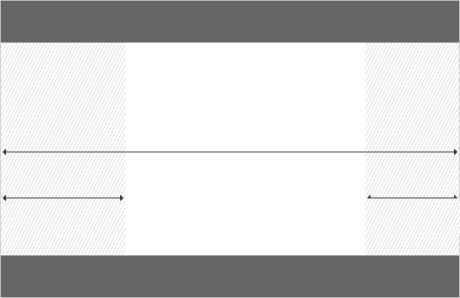
TOPBAR
STYLES |  | INSTRUCTION
<div id=“topbar"> Top Bar</div>  <div id="leftnav">Left Navigation </div>  <div id="content">Content Section</div>  <div id="rightnav">Right Navigation </div>  <div id=“bottombar">Bottom Bar/div> |  | Put enough <div> tags into your HTML in order to create the layout shown to the left
#topbar {  background: #0f0;  position: absolute;  top: 0px;  left: 0px;  width: 800px;  height: 100px;} |  | Using the ID Selector topbar (you can change the name if you wish) and the attached declaration (shown left), you can create the top section of the document (as shown above left)  Create ID Selectors for the other 4 sections of the layout and modify the CSS shown to size/position them.
TASK 4: POSITIONING DIVS USING CSS LIQUID LAYOUTS

Using absolute positions and fixed widths for your DIVs (as in task 4) can be both tricky and problematic as the result of your layout is resolution dependent and may not achieve the desired result on some monitors. The most common solution is to use liquid layouts which:

- Use %age values for width.

- Use Floats to position the DIVS.

- Will allow the layout to resize with the size of the browser window.

- Use margin values to create space between the Divs.

1). Edit the code below to create a 3 column layout

3). Change the widths to create different layouts and add formatting (color etc.).

4). Add footer DIV and position it by clearing the floats.
<!DOCTYPE HTML PUBLIC "-//W3C//DTD HTML 4.01//EN"
"http://www.w3.org/TR/html4/strict.dtd">
<html>
<head>
<title> CT4009 WEEK 7</title>
</head>
<body>
<div> COLUMN 1 CONTENT TO PLACED HERE</div>
<div> COLUMN 2 CONTENT TO PLACED HERE </div>
</body>
</html>
STYLES |  | INSTRUCTION
#col1  {  float: left;  width: 48%;  margin-left: 3%;  }  #col2  {  float: left;  width: 20%;  margin-left: 3%; }  #footer { clear: both; } |  | The CSS shown left uses ID Selectors to position the DIVs using floats and sizes them using %age widths  Add formatting attributes and values (background colours etc) to distinguish the individual areas of the layout  Add a footer DIV to the HTML and attach the ID Selector which clears the previous floats and sends the DIV to the bottom of the layout
SELF-STUDY: ADDING CONTENT AND FURTHER TAGS
1). Upon Completion of tutorial tasks, experiment further with CSS, positioning <div> tags and elements contained with HTML created thus far. You should try to demonstrate your attempts to use:
- Absolutely Positioned DIVs
- Floated DIVs
- Liquid Layouts using %age Width DIVs
2). Continue to experiment with HTML, adding further content (text and images) to your documents.

3). Experiment with the formatting possibilities of CSS, demonstrating these differences and illustrating the techniques within your HTML.

4). Use these tools and techniques to create initial prototype layouts for you portfolio site.
Good introductory material and practical exercises can be found at:

http://www.w3schools.com/css/default.asp
http://www.csszengarden.com/
http://meyerweb.com/eric/css/edge/ 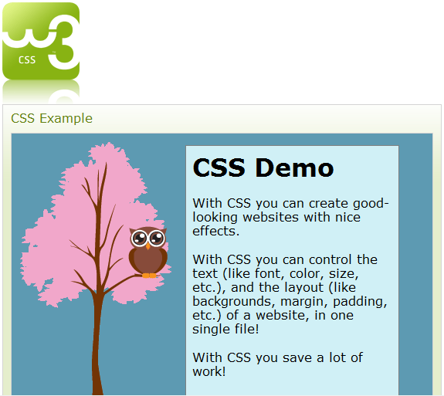
You should also take screengrabs of your HTML, the CSS which you create and the resultant documents (as rendered via a browser) and integrate these into Evaluation Document. The illustration and discussion of code can be difficult to present effectively, so ensure that you have looked at the Evaluation Document Guidelines available on the module website.

If you have successfully completed the Tutorial Exercises, you could spend the remaining study time reading the recommended textbook. Alternatively, you could review this week’s lecture notes or look ahead to next week’s topics. Remember that you are free to use the labs as long as they are not booked for another lesson; they tend to be very quiet early in the morning and in the evenings!

It is important that you read through the module guide several times throughout the semester so that you have a thorough understanding of the requirements of the module, particularly the assignments.

Starting planning your portfolio for assignment 1 by considering things such as what media you may already have that could be included, e.g. photographs etc. Are these available locally? Do they need to be scanned or digitised? If you do not have your own digital camera or camcorder you should think about borrowing these from the technicians – plan for this by booking in advance. Also, it would be appropriate to keep a written diary of your html / authoring experiences so that you can use them later on in the assignment and include them in your Evaluation Document. This could be rough notes, sketches or possibly screen shots, add to them as thoughts come to mind – it is too easy to forget excellent ideas you had late at night or early in the morning!

NB: If you did not manage to complete all of the tutorial exercise in the time available during your allotted lab session, you must endeavor to catch up during the self-directed study time.

